Themenblock 9: Money & the Globalized World

CATEGORY A: CONTRASTING IMAGES

TASK SET A1: The Divided City

PART 1 — Individual Long Turn



Task:
Give a five-minute talk on wealth inequality and urban development in which you
• Describe, compare and contrast the pictures above.
• Analyze the factors that contribute to visible wealth inequality in modern cities.
• Discuss what responsibility wealthy individuals and governments might have to address economic disparities.

PART 2 — Paired Activity
Task:
Your school is organizing an exhibition called "Two Sides of the City" to raise awareness about economic inequality in urban areas. You and your partner are on the planning committee. Discuss the following aspects and agree on three to prioritize:
• Personal stories: interviews with residents from different neighborhoods
• Statistical displays: infographics showing wealth distribution data
• Interactive elements: activities that simulate economic decision-making
• Historical context: how inequality has changed over decades
• Solutions showcase: examples of successful policies from other cities

TASK SET A2: The Social Media Money Illusion

PART 1 — Individual Long Turn



Task:
Give a five-minute talk on social media, money, and authenticity in which you
• Describe, compare and contrast the pictures above.
• Analyze why people project false images of wealth on social media.
• Discuss how social media has influenced young people's attitudes toward money and spending habits.

PART 2 — Paired Activity
Task:
Your school's psychology class is conducting research on social media's influence on young people's financial behavior. You and your partner are designing the research focus. Discuss these research questions and agree on three to prioritize:
• How does seeing 'rich lifestyle' content affect spending decisions?
• What is the relationship between social media use and credit card debt?
• Do young people feel pressure to spend money for social media content?
• How do influencer promotions affect purchasing behavior?
• What role does financial education play in resisting social media spending pressure?

TASK SET A3: Decisions at the Checkout

PART 1 — Individual Long Turn


Task:
Give a five-minute talk on consumer psychology and mindful spending in which you
• Describe, compare and contrast the illustrations above.
• Analyze the psychological factors that drive impulse buying behavior.
• Discuss strategies for becoming a more mindful consumer.

PART 2 — Paired Activity
Task:
Your school is creating a "Smart Spending" campaign to help students make better financial decisions. You and your partner are designing the campaign content. Discuss the following campaign elements and agree on three to include:

• A 'Wait 48 Hours' challenge before non-essential purchases
• Testimonials from students about their impulse buying regrets
• A budgeting app recommendation and tutorial
• Tips for recognizing and resisting marketing tricks
• A 'No-Spend Week' challenge with prizes for participants

CATEGORY B: QUOTES

TASK SET B1: Money and Happiness

PART 1 — Individual Long Turn
Quote 1:
"It is good to have money and the things that money can buy, but it's good, too, to check up once in a while and make sure you haven't lost the things that money can't buy."
— George Horace Lorimer, Editor-in-Chief, The Saturday Evening Post
Quote 2:
"When you have more money, you have more choices about how to live your life. Across decisions big and small, having more money gives a person more choices and a greater sense of autonomy."
— Matthew Killingsworth, Researcher, University of Pennsylvania
Task:
Give a five-minute talk on money, success, and happiness in which you
• Critically analyze the two quotes above and state your opinion on each perspective.
• Discuss whether money can truly buy happiness, using examples from society and your own observations.
• Evaluate what factors besides money contribute to a fulfilling life.

PART 2 — Paired Activity
Task:
You are a young professional just starting your career. Together with a financial advisor, you are planning your approach to money and life goals. Discuss the following life priorities and agree on three to focus on in your first five years of working:
• Maximizing income through career advancement and job changes
• Building an emergency fund and saving for the future
• Investing in experiences and travel while young
• Maintaining work-life balance even if it means lower salary
• Giving back through charitable donations or volunteer work

TASK SET B2: Consumption and Sustainability

PART 1 — Individual Long Turn
Quote 1:
"You cannot run a linear system on a finite planet indefinitely."
— Annie Leonard, Environmentalist and Author
Quote 2:
"Humanity's 21st century challenge is to meet the needs of all within the means of the planet."
— Kate Raworth, Economist and Author
Task:
Give a five-minute talk on sustainable consumption and the global economy in which you
• Analyze and compare the two quotes above.
• Discuss the conflict between economic growth and environmental sustainability.
• Outline possible solutions for creating a more sustainable global economy.

PART 2 — Paired Activity
Task:
You have been granted a ten-minute meeting with your country's Environment Minister to discuss youth concerns about sustainable consumption and economic policy. Before your meeting, discuss these topics and agree on three to focus on:

• Banning planned obsolescence in electronics and appliances
• Introducing a carbon tax on imported goods
• Mandating sustainability education in all schools
• Subsidizing repair shops and second-hand markets
• Setting binding corporate waste reduction targets

CATEGORY C: ALTERNATIVE PROMPTS

TASK SET C1: The Inequality Explosion

PART 1 — Individual Long Turn
Text Extract:
In 2024, the combined wealth of the world's billionaires increased by $2 trillion—the second-largest annual rise ever recorded. Five individuals are now expected to become trillionaires within a decade. Meanwhile, according to Oxfam's latest analysis, 60% of billionaire wealth comes from inheritance, monopoly power, or cronyism rather than innovation or hard work. The richest 1% of humanity now owns nearly 45% of all global wealth, while 44% of the world's population—over 3.5 billion people—lives below the poverty line of $6.85 per day. In 2024 alone, 204 new billionaires were created—roughly four every week. — Adapted from Oxfam International, "Takers Not Makers" Report, January 2025
Task:
Give a five-minute talk on global wealth inequality in which you
• Analyze the information presented in the text extract and highlight its key findings.
• Discuss whether extreme wealth inequality can be effectively addressed through policy.
• Evaluate the argument that billionaires are 'takers not makers' and consider counterarguments.

PART 2 — Paired Activity
Task:
Your school is hosting a debate on the motion: "Billionaires should be taxed at 70% on wealth above one billion dollars." Take opposing positions and discuss the following aspects:
• The fairness of taxing wealth that has already been taxed as income
• Whether high taxes would cause billionaires to leave the country
• The potential uses of tax revenue for public services
• The impact on innovation and entrepreneurship
• Whether governments can be trusted to spend the money well

TASK SET C2: Generation Debt: The Gen Z Financial Paradox

PART 1 — Individual Long Turn
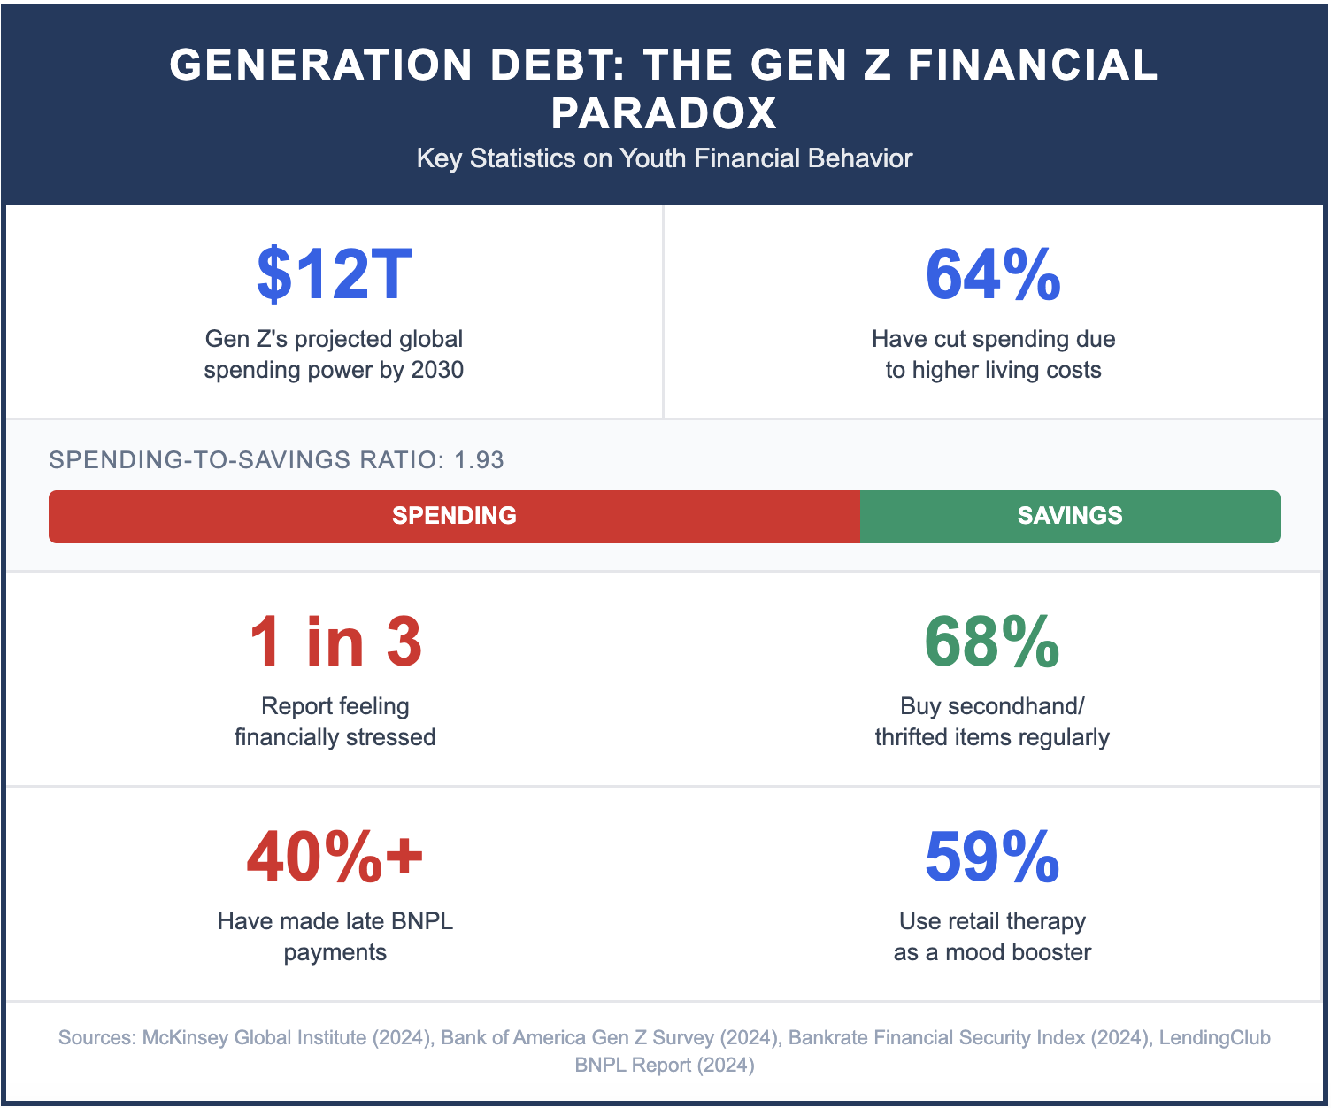

Task:
Give a five-minute talk on youth financial behavior and the economy in which you
• Explain the phenomenon of the 'Gen Z financial paradox' based on the statistics presented.
• Analyze why young people display contradictory financial behaviors – being thrifty yet overspending.
• Discuss what these trends mean for your generation's financial security and the broader economy.

PART 2 — Paired Activity
Task:
Your school wants to launch a financial literacy program specifically designed for Gen Z students. You and your partner are helping design the curriculum. Discuss the topics below and agree on three to include as core modules:
• Understanding and avoiding Buy Now Pay Later debt traps
• Creating and sticking to a realistic monthly budget
• The psychology of spending: why we buy what we don't need
• Investing basics: making your money grow over time
• Navigating the cost of living crisis: practical money-saving tips

